Paper Title* (use style: paper title)

*Note: Sub-titles are not captured in Xplore and should not be used

line 1: 1st Given Name Surname   
line 2: *dept. name of organization   
(of Affiliation)*  
line 3: *name of organization   
(of Affiliation)*line 4: City, Country  
line 5: email address or ORCID

line 1: 4th Given Name Surname  
line 2: *dept. name of organization*  
*(of Affiliation)*  
line 3: *name of organization   
(of Affiliation)*line 4: City, Country  
line 5: email address or ORCIDline 1: 2nd Given Name Surname  
line 2: *dept. name of organization   
(of Affiliation)*  
line 3: *name of organization   
(of Affiliation)*line 4: City, Country  
line 5: email address or ORCID

line 1: 5th Given Name Surname  
line 2: *dept. name of organization   
(of Affiliation)*  
line 3: *name of organization   
(of Affiliation)*line 4: City, Country  
line 5: email address or ORCIDline 1: 3rd Given Name Surname  
line 2: *dept. name of organization   
(of Affiliation)*  
line 3: *name of organization   
(of Affiliation)*line 4: City, Country  
line 5: email address or ORCID

line 1: 6th Given Name Surname  
line 2: *dept. name of organization   
(of Affiliation)*  
line 3: *name of organization   
(of Affiliation)*line 4: City, Country  
line 5: email address or ORCID

*Abstract*—This electronic document is a “live” template and already defines the components of your paper [title, text, heads, etc.] in its style sheet. *\*CRITICAL: Do Not Use Symbols, Special Characters, Footnotes, or Math in Paper Title or Abstract*. (*Abstract*)

Keywords—component, formatting, style, styling, insert (key words)

# Introduction (*Heading 1*)

This template, modified in MS Word 2007 and saved as a “Word 97-2003 Document” for the PC, provides authors with most of the formatting specifications needed for preparing electronic versions of their papers. All standard paper components have been specified for three reasons: (1) ease of use when formatting individual papers, (2) automatic compliance to electronic requirements that facilitate the concurrent or later production of electronic products, and (3) conformity of style throughout a conference proceedings. Margins, column widths, line spacing, and type styles are built-in; examples of the type styles are provided throughout this document and are identified in italic type, within parentheses, following the example. Some components, such as multi-leveled equations, graphics, and tables are not prescribed, although the various table text styles are provided. The formatter will need to create these components, incorporating the applicable criteria that follow.

# Ease of Use

## Selecting a Template (Heading 2)

First, confirm that you have the correct template for your paper size. This template has been tailored for output on the A4 paper size. If you are using US letter-sized paper, please close this file and download the Microsoft Word, Letter file.

## Maintaining the Integrity of the Specifications

The template is used to format your paper and style the text. All margins, column widths, line spaces, and text fonts are prescribed; please do not alter them. You may note peculiarities. For example, the head margin in this template measures proportionately more than is customary. This measurement and others are deliberate, using specifications that anticipate your paper as one part of the entire proceedings, and not as an independent document. Please do not revise any of the current designations.

# coding

We have 4 different tasks that we need to solve. Each task has different maps and different condition to fulfill. Our main purpose throughout this project is that our ResQ robot (R)would be able to reach the target whether the target is on the water(t) or on land mode(T). To reach the target, the robot must be able to destroy obstacles (*), avoid from hitting the walls(#) and changing the mode. For example, by changing the mode from water mode to land mode. In order to fulfill the task requirement, we have decided to use the Breadth First Search algorithm (BFS).

## Breadth First Search Algorithm

Breadth first search is an algorithm for finding shortest path to reach the target or solve puzzle. BFS works best when there is a concept of layers or levels of neighborhoods in the graph we are dealing with. The BFS algorithm starts from a root vertex and explores the vertices in the neighborhood vertices. It then moves to the next neighborhood level and repeats the process [2]. For breadth-first search (BFS), the set Open is realized as a first-in first-out queue (FIFO). The Insert operation is called Enqueue and adds an element to the end of the list; the Dequeue operation selects and removes its first element. As a result, the neighbors of the source node are generated layer by layer (one edge apart, two edges apart, and so on) then, BFS stops as soon as it generates the goal [1].

### Initialization

We will use two data structures:

* visited: This contains all the vertices that have been visited. Initially, it will be empty [2].
* queue: This contains all the vertices that we have want to visit in next iterations [2].

### The main loop

### 

Next, we will implement the main loop. It will keep on looping until there is not even a single element in the queue. For each node in the queue, if it has already been visited, then it visits its neighbor [2].

## Task 1

At the beginning, we only need to move the robot to find target without any obstacles. The robot only requires avoiding from hitting the walls (#) and reach the target which located on land. In this part, we only have one map that need to be tested. The map is shown in figure 1.

1. Map for task 1.

### Pseudocode

* Find robot position.
* Find target position.
* Find row and column of robot in the map.
* Find row and column of target in the map.
* Find column difference between robot and target.
* Find row difference between robot and target.
* If column difference greater than 0, move south.
* If column difference less than 0, move north.
* If row difference greater than 0, move east.
* If row difference less than 0, move west.

### Code

Based on pseudocode, we implement the code as shown in figure 2.

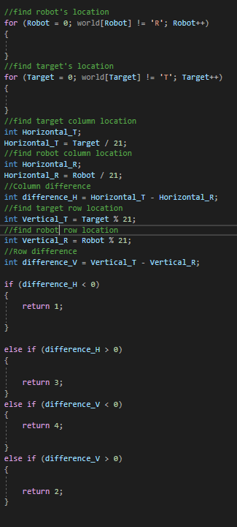

1. Code for task 1

## Task 2

Now the task is quite challenging as the walls are located randomly, not just on the border. The maps are shown in figure 3. Furthermore, robot will be able to move both on water and on land by changing its mode either land mode or water mode. To reach the target without any crash or failure, the robot requires to find the shortest path to the target by avoiding the walls and switch the mode correctly.

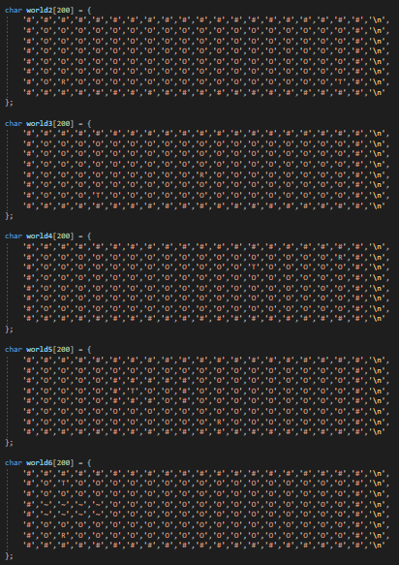

1. Maps for task 2

### Pseudocode

* Find target and robot position.
* Make array for “queue”.
* Put initial robot position in the first “queue”.
* Make array for “visited “and fill it with null.
* Mark current robot position as visited.
* Make “previous” array for previous node and fill it with null.
* Make loop to check neighbor of nodes until target is found.
* If neighbor nodes is not wall and obstacle (for task 3), then put node in “queue” array.
* Mark the node as visited from avoiding checking the same node.
* Keep track of node in array “previous”.
* Call “previous” array to construct reverse path (from target to robot).
* Use reverse path to construct correct path (from robot to target).
* If there is water in path, change the robot mode from land to water mode.
* Move robot to target according to the correct path.

### Code

Based on pseudocode, we implement the code as shown in figure 2.

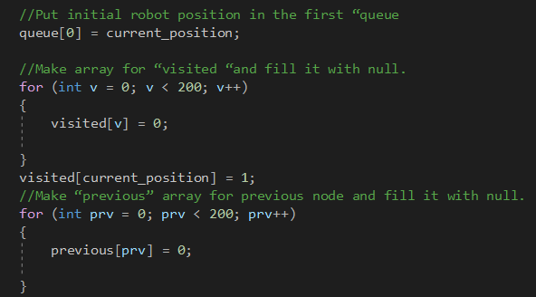

1. 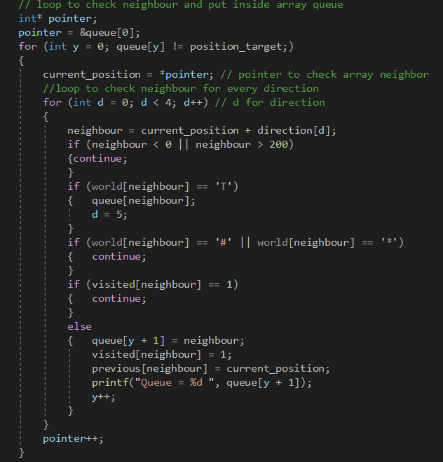Construct visited array and previous node array.
2. Fill up queue array and check neighbor.
3. 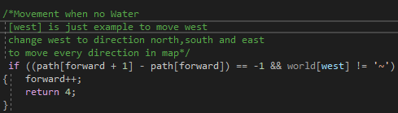Array for reverse path and correct path
4. 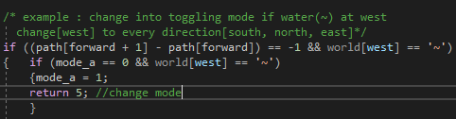Movement of robot on land in west direction   
   as example.
5. 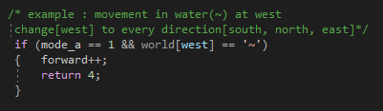Change mode from water mode to   
   land mode (west as example)
6. Movement of robot in water in direction west as example.

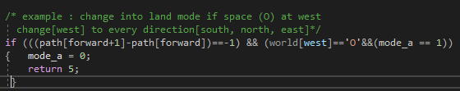

1. Change back water mode to land mode (west as example)

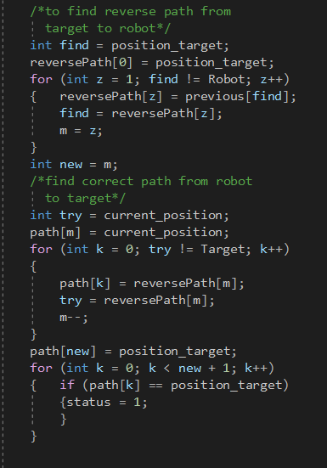

## Task 3

After finding the shortest path in task 2, our robot can manage to return to its original position where it is located at first for task 3. Instead of only to keep away from hitting the walls, robot has included with new features which is avoiding the obstacles (*) and use less energy. In this task also, we have extra two maps as shown in figure…

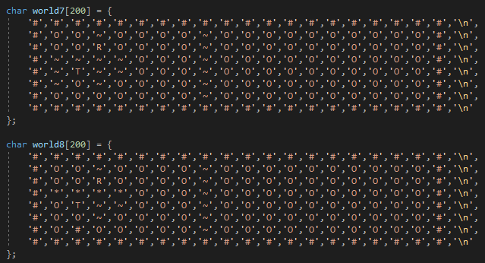

1. Maps for task 3

### Pseudocode

* For the first step, follow pseudocode task 2.
* Move the robot back to its initial position using reverse path.
* If in reverse path has water or land, then change robot mode from land mode to water mode and vice versa.

### Code

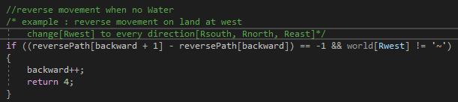

1. 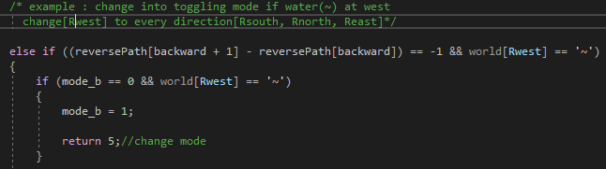Reverse movement of robot on land in west direction   
   as example
2. 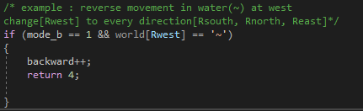Change mode from water mode to   
   land mode (west as example) in reverse path.
3. Reverse movement of robot in water in direction west as example.
4. Change back water mode to land mode (west as example) in reverse path.

## Task 4

For this task, the target is located not only on land(T) but also on water(t). As task 3, the robot is assigned to avoid obstacles but, in this task, the robot can destroy the obstacles in any direction which is North, South, West and East in order to reach the target faster.

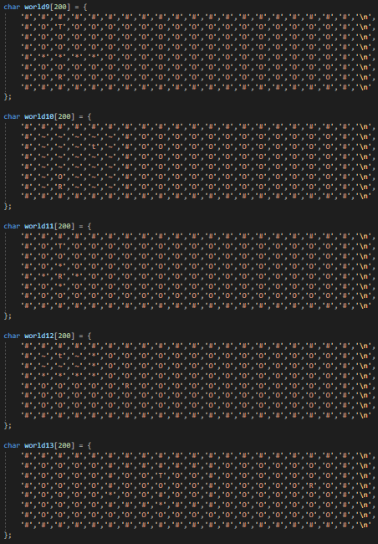

1. Maps for task 4

### Pseudocode

* For the first step, follow pseudocode task 2, but consider obstacles to put in the “queue” array.
* If in correct path, there is obstacles, then robot will destroy obstacles.
* Move the robot back to its initial position using reverse path.
* If in reverse path has water or land, then change robot mode from land mode to water mode and vice versa.

### Code

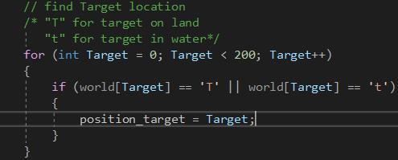

1. “t” is included for task 4 as target.

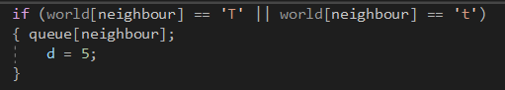

1. “t” is added to fill up queue array and check neighbor.

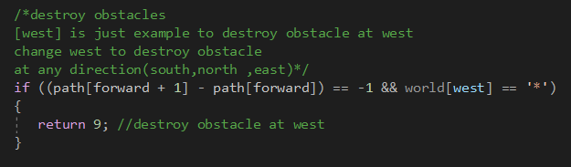

1. Destroy obstacle at west as example.

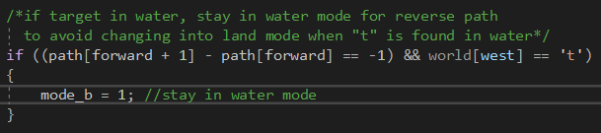

1. Stay in water mode when “t” is found.

* r.Using the Template

After the text edit has been completed, the paper is ready for the template. Duplicate the template file by using the Save As command, and use the naming convention prescribed by your conference for the name of your paper. In this newly created file, highlight all of the contents and import your prepared text file. You are now ready to style your paper; use the scroll down window on the left of the MS Word Formatting toolbar.

## Authors and Affiliations

**The template is designed for, but not limited to, six authors.** A minimum of one author is required for all conference articles. Author names should be listed starting from left to right and then moving down to the next line. This is the author sequence that will be used in future citations and by indexing services. Names should not be listed in columns nor group by affiliation. Please keep your affiliations as succinct as possible (for example, do not differentiate among departments of the same organization).

### For papers with more than six authors: Add author names horizontally, moving to a third row if needed for more than 8 authors.

### For papers with less than six authors: To change the default, adjust the template as follows.

#### Selection: Highlight all author and affiliation lines.

#### Change number of columns: Select the Columns icon from the MS Word Standard toolbar and then select the correct number of columns from the selection palette.

#### Deletion: Delete the author and affiliation lines for the extra authors.

## Identify the Headings

Headings, or heads, are organizational devices that guide the reader through your paper. There are two types: component heads and text heads.

Component heads identify the different components of your paper and are not topically subordinate to each other. Examples include Acknowledgments and References and, for these, the correct style to use is “Heading 5”. Use “figure caption” for your Figure captions, and “table head” for your table title. Run-in heads, such as “Abstract”, will require you to apply a style (in this case, italic) in addition to the style provided by the drop down menu to differentiate the head from the text.

Text heads organize the topics on a relational, hierarchical basis. For example, the paper title is the primary text head because all subsequent material relates and elaborates on this one topic. If there are two or more sub-topics, the next level head (uppercase Roman numerals) should be used and, conversely, if there are not at least two sub-topics, then no subheads should be introduced. Styles named “Heading 1”, “Heading 2”, “Heading 3”, and “Heading 4” are prescribed.

## Figures and Tables

#### Positioning Figures and Tables: Place figures and tables at the top and bottom of columns. Avoid placing them in the middle of columns. Large figures and tables may span across both columns. Figure captions should be below the figures; table heads should appear above the tables. Insert figures and tables after they are cited in the text. Use the abbreviation “Fig. 1”, even at the beginning of a sentence.

1. Table Type Styles

| Table Head | Table Column Head | | |
| --- | --- | --- | --- |
| Table column subhead | Subhead | Subhead |
| copy | More table copya |  |  |

1. Sample of a Table footnote. (*Table footnote*)
2. Example of a figure caption. (*figure caption*)

Figure Labels: Use 8 point Times New Roman for Figure labels. Use words rather than symbols or abbreviations when writing Figure axis labels to avoid confusing the reader. As an example, write the quantity “Magnetization”, or “Magnetization, M”, not just “M”. If including units in the label, present them within parentheses. Do not label axes only with units. In the example, write “Magnetization (A/m)” or “Magnetization {A[m(1)]}”, not just “A/m”. Do not label axes with a ratio of quantities and units. For example, write “Temperature (K)”, not “Temperature/K”.

##### Acknowledgment *(Heading 5)*

The preferred spelling of the word “acknowledgment” in America is without an “e” after the “g”. Avoid the stilted expression “one of us (R. B. G.) thanks ...”. Instead, try “R. B. G. thanks...”. Put sponsor acknowledgments in the unnumbered footnote on the first page.

##### References

The template will number citations consecutively within brackets [1]. The sentence punctuation follows the bracket [2]. Refer simply to the reference number, as in [3]—do not use “Ref. [3]” or “reference [3]” except at the beginning of a sentence: “Reference [3] was the first ...”

Number footnotes separately in superscripts. Place the actual footnote at the bottom of the column in which it was cited. Do not put footnotes in the abstract or reference list. Use letters for table footnotes.

Unless there are six authors or more give all authors’ names; do not use “et al.”. Papers that have not been published, even if they have been submitted for publication, should be cited as “unpublished” [4]. Papers that have been accepted for publication should be cited as “in press” [5]. Capitalize only the first word in a paper title, except for proper nouns and element symbols.

For papers published in translation journals, please give the English citation first, followed by the original foreign-language citation [6].

1. S. Schrödl and S. Edelkamp, Heuristic Search: Theory and Applications. Morgan Kaufmann Publishers, 2011.
2. I. Ahmad, 40 Algorithms Every Programmer Should Know. [S.l.]: Packt Publishing, 2020.
3. . S. Jacobs and C. P. Bean, “Fine particles, thin films and exchange anisotropy,” in Magnetism, vol. III, G. T. Rado and H. Suhl, Eds. New York: Academic, 1963, pp. 271–350.
4. K. Elissa, “Title of paper if known,” unpublished.
5. R. Nicole, “Title of paper with only first word capitalized,” J. Name Stand. Abbrev., in press.
6. Y. Yorozu, M. Hirano, K. Oka, and Y. Tagawa, “Electron spectroscopy studies on magneto-optical media and plastic substrate interface,” IEEE Transl. J. Magn. Japan, vol. 2, pp. 740–741, August 1987 [Digests 9th Annual Conf. Magnetics Japan, p. 301, 1982].
7. M. Young, The Technical Writer’s Handbook. Mill Valley, CA: University Science, 1989.

**IEEE conference templates contain guidance text for composing and formatting conference papers. Please ensure that all template text is removed from your conference paper prior to submission to the conference. Failure to remove template text from your paper may result in your paper not being published.**

We suggest that you use a text box to insert a graphic (which is ideally a 300 dpi TIFF or EPS file, with all fonts embedded) because, in an MSW document, this method is somewhat more stable than directly inserting a picture.

To have non-visible rules on your frame, use the MSWord “Format” pull-down menu, select Text Box > Colors and Lines to choose No Fill and No Line.